**EXPERIMENT-25**

**MICROSOFT AZURE**

Create a SQL storage service and perform a basic query using any Public Cloud Service Provider (Azure/GCP/AWS) to demonstrate Database as a Service (DaaS).

STEP-1: CREATE A SQL DATA BASE SERVER.

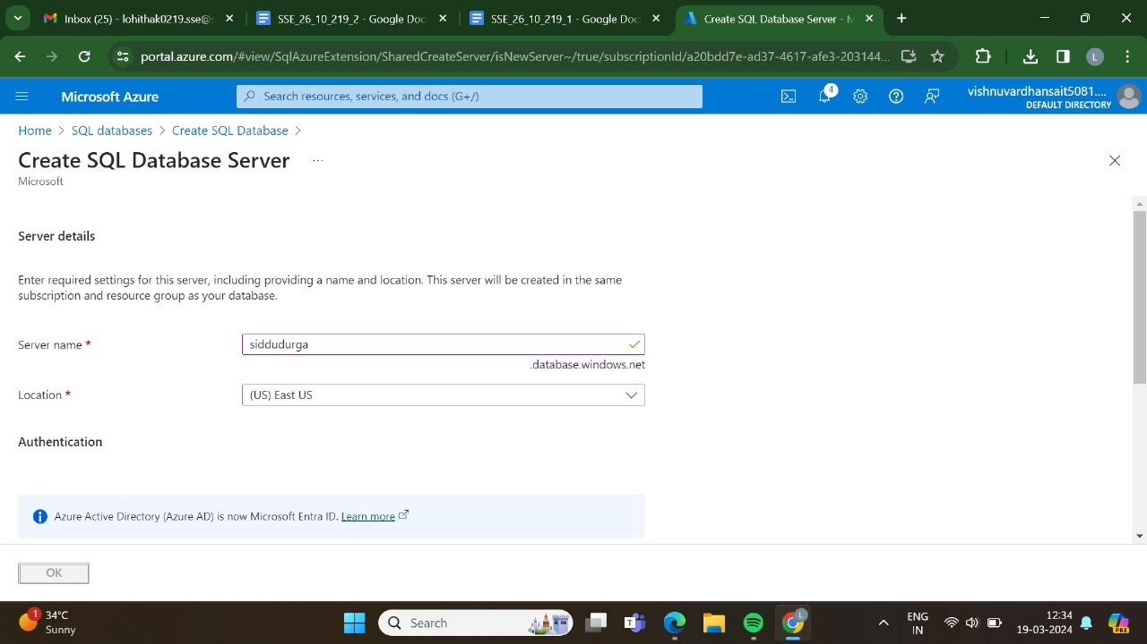

STEP-2:AND,THEN GO FOR THE BASICS.

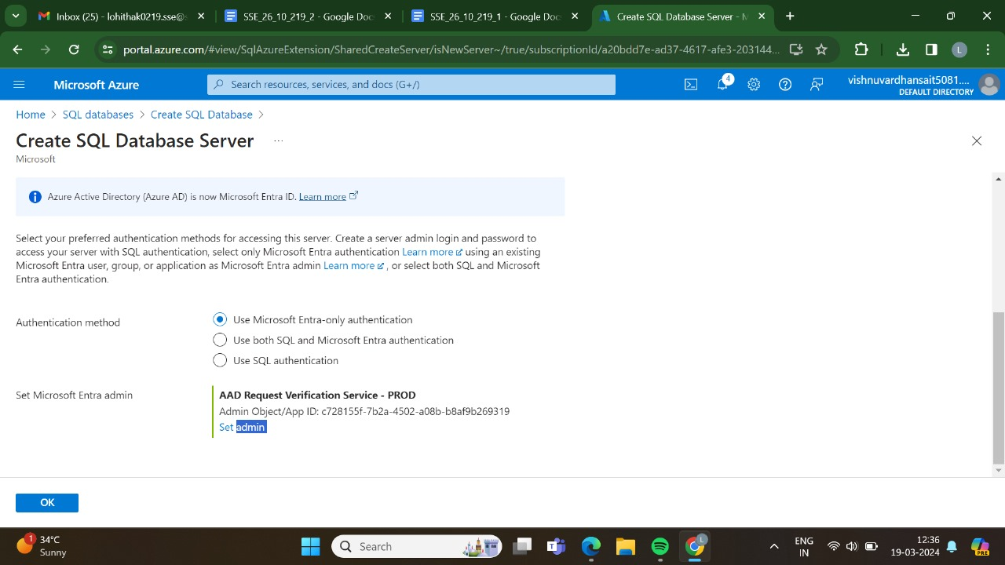

STEP-3:AND ,THEN GO FOR THE NETWORKING.

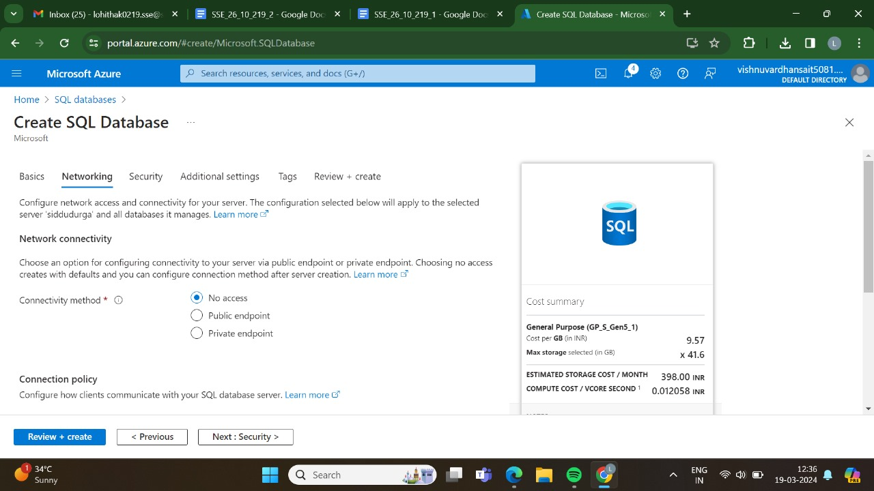

STEP-4:AND,THEN GO FOR THE SECURITY.

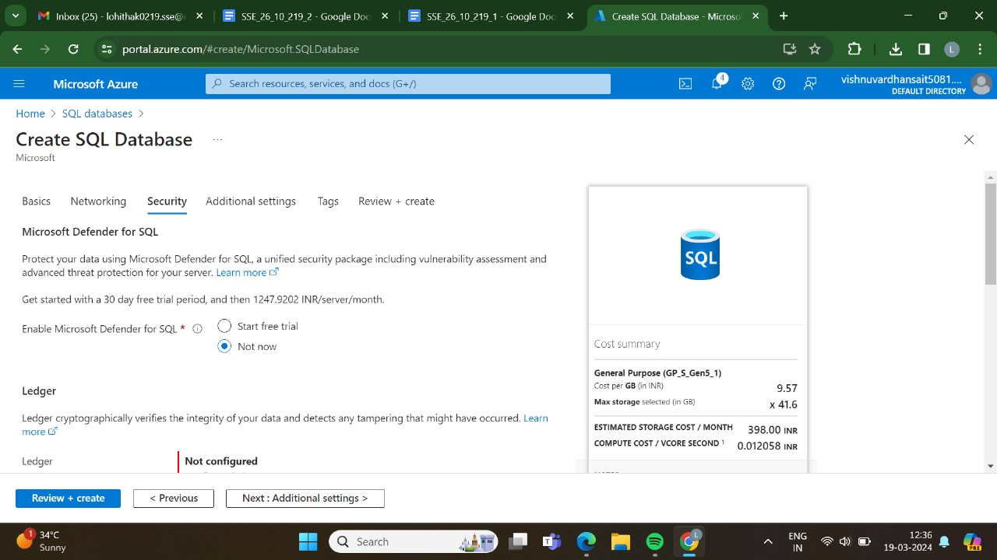

STEP-5: AND,THEN GO FOR THE ATTIDIONAL SETTINGS.

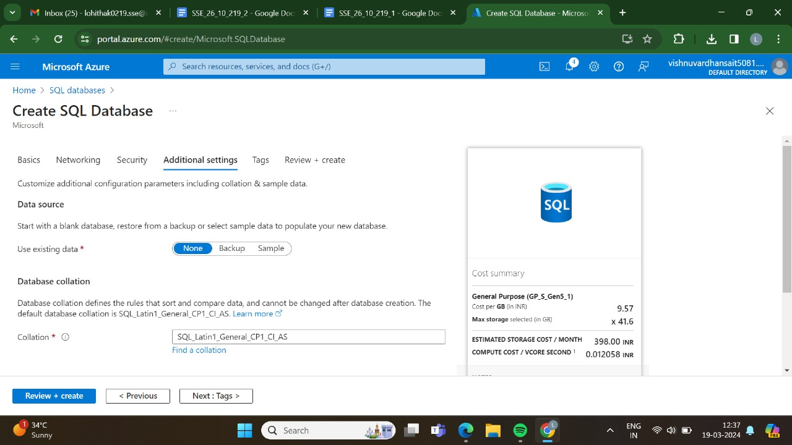

STEP-6: AND,THEN GO FOR THE TAGS.

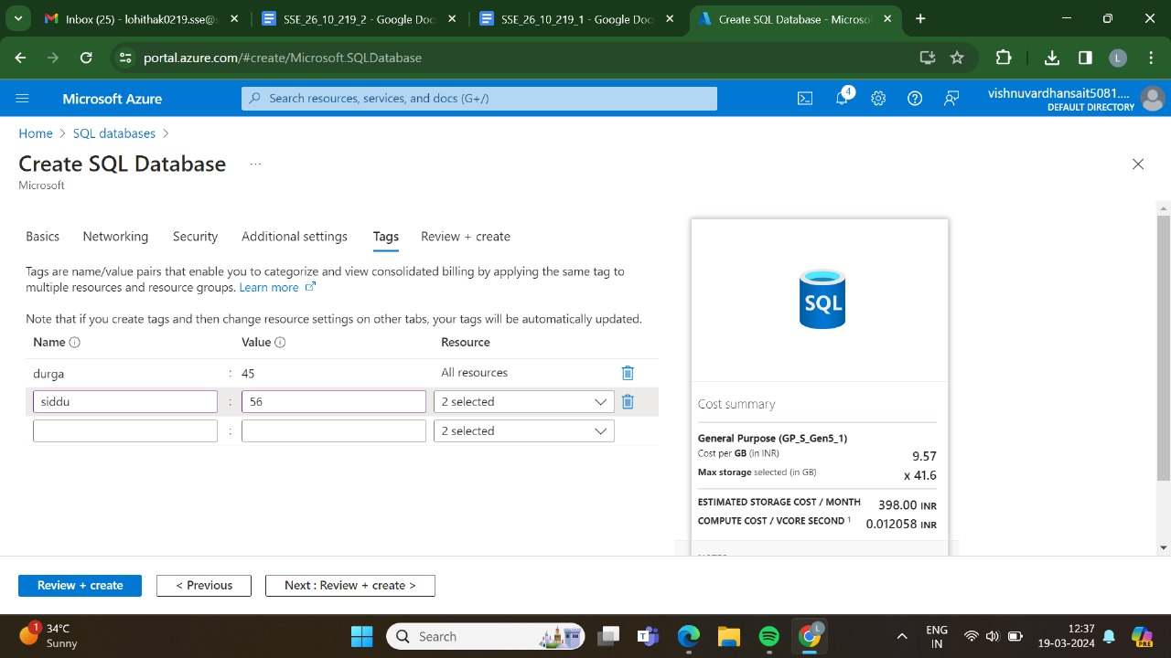

STEP-7:AND,THEN GO FOR THE REVIEW +CRAETE AND CLICK CREATE.

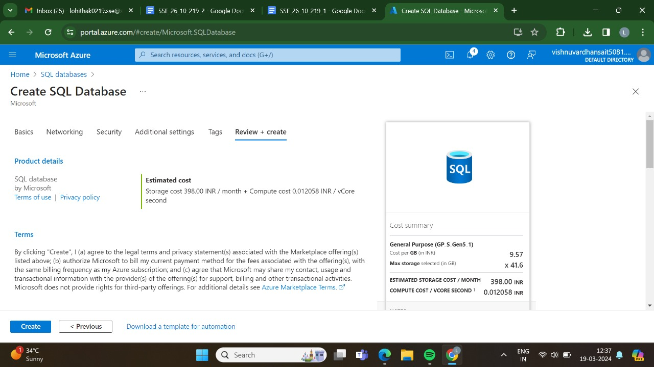

STEP-8: AND THEN GO FOR THE CREATE.



STEP-9:DEPLOYMENT IS IN PROGRESS.

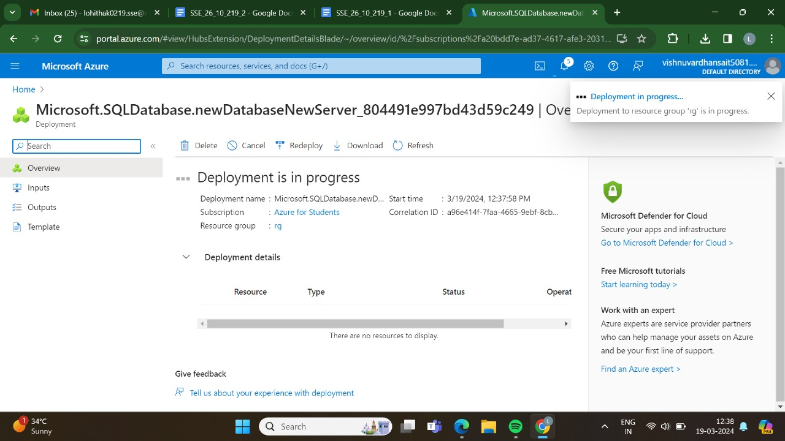

STEP-10:THE DEPLOYMENT HAS BEEN DONE SUCCESSFULLY.

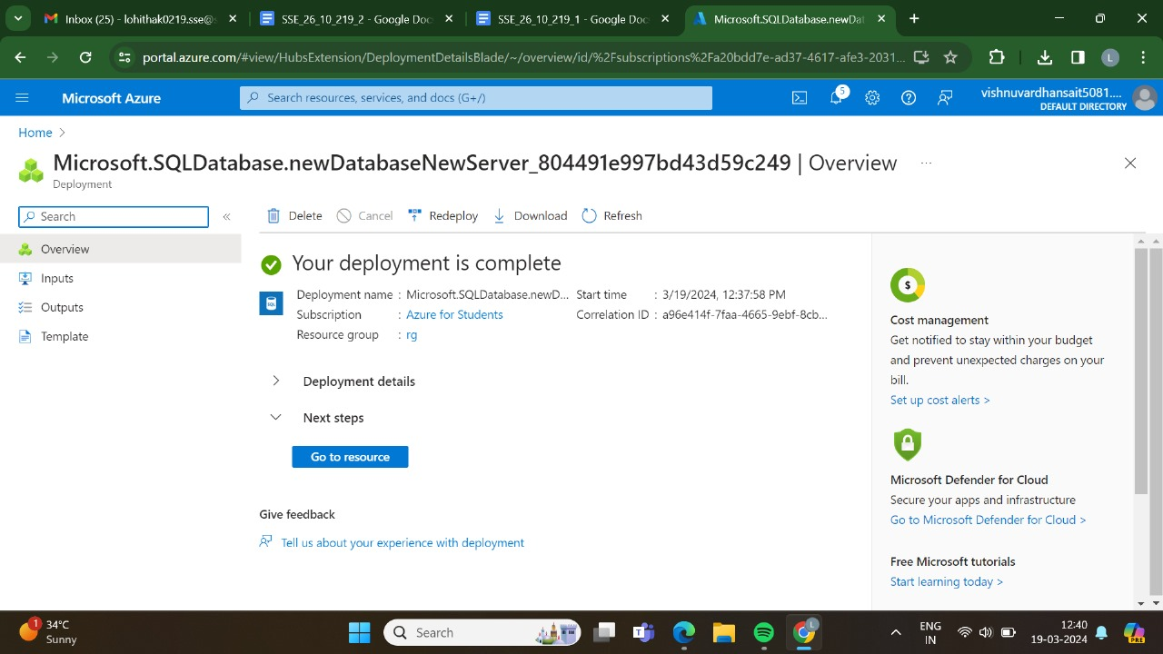

STEP-11:HERE,IS THE OUTPUT FOR THE SQL DATABASE SERVER.

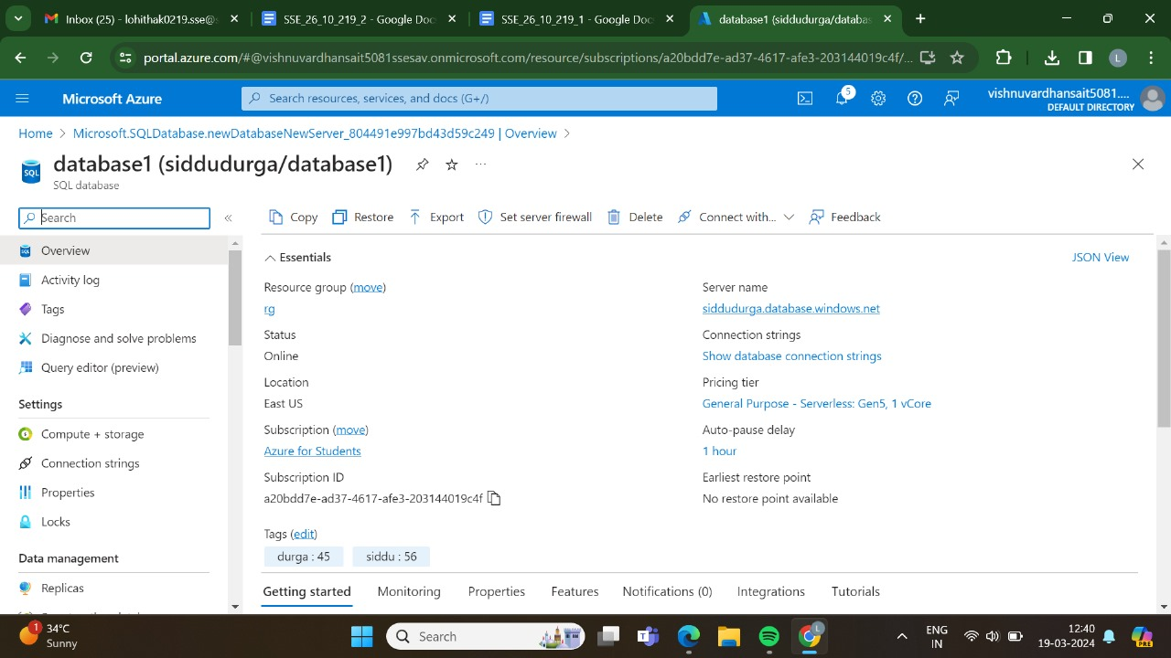

RESULT:THUS,THE PROGRAM HAS BEEN EXCEUTED SUCCESSFULLY.